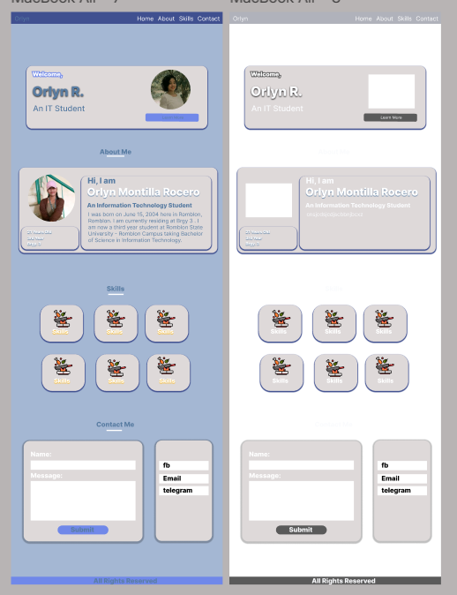

home

about

skills

contact

logo

name

logo

All rights reserved

Fb

tg

Skills

details

Contact Me

skills

skills

skills

skills

skills

skills

About Me

name

quote